1. Number of Clients V/S Average Active Threads

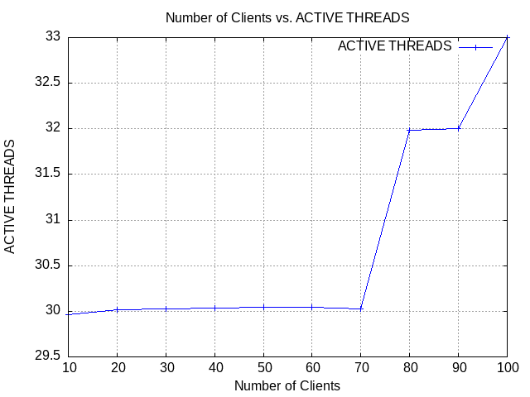

2. Number of Clients V/S Error Rate

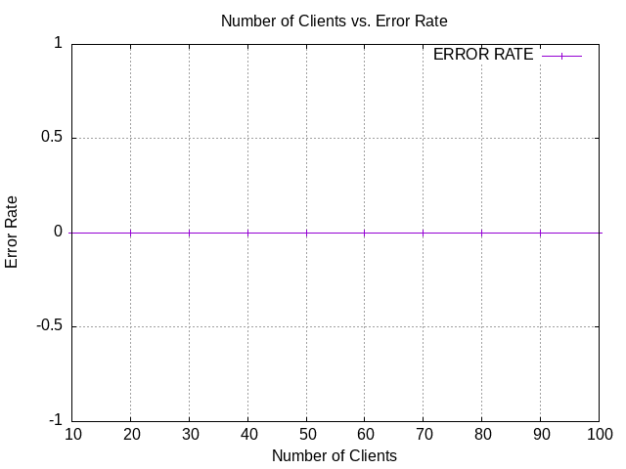

3. Number of Clients V/S Request Sent Rate

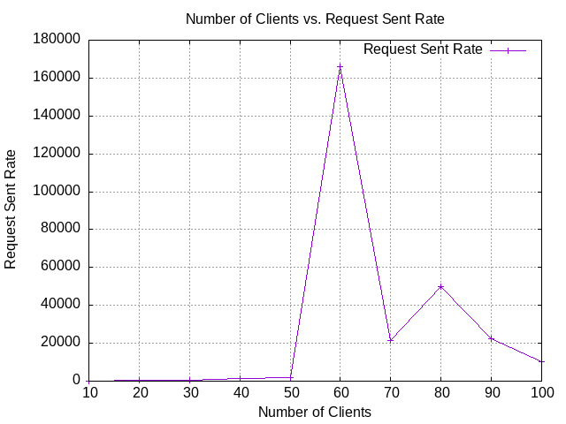

4. Number of Clients V/S Response Time

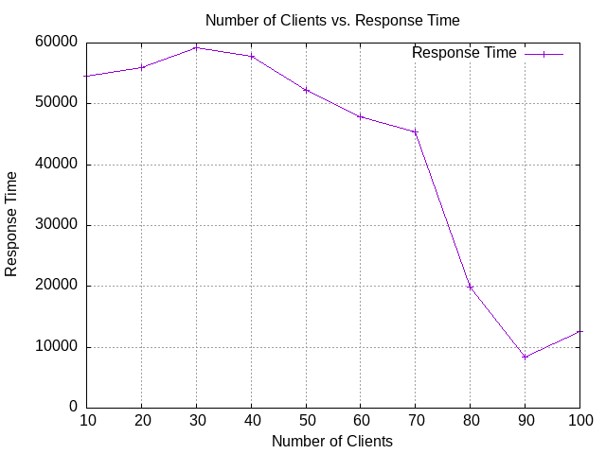

5. Number of Clients V/S Throughput

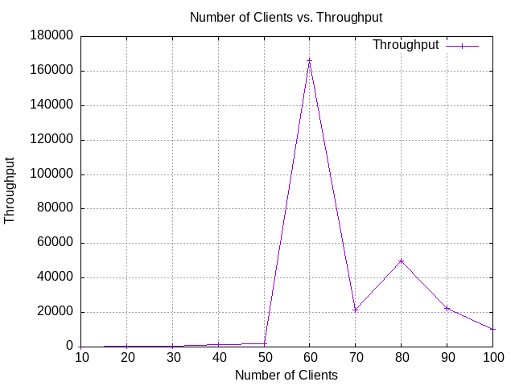

6. Number of Clients V/S Timeout Rate

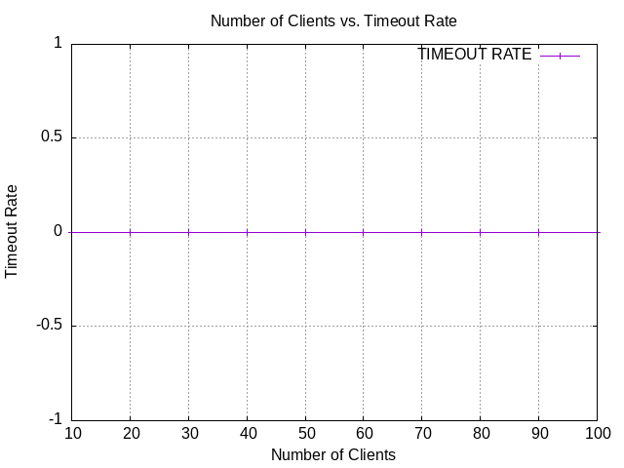

7. Number of Clients V/S CPU Utilization

